Journal of Statistics, Volume pp. |  | ISSN 1684-8403

Title of the Research Paper

Author A*, Author B, Author C2 and Author D

Abstract

Abstract should briefly state the purpose of the research, the principal results, and major conclusions. Abstract should not exceed 250 words. Abstract should not include references or equations. Abbreviations are not allowed in the Abstract. Four or five keywords should be given immediately after the Abstract. Abstract text in Times New Roman 12

Keywords

Keyword1, Keyword2, Keyword3 in Times New Roman 12

Mathematical Subject Classification

Text in Times New Roman 12

Introduction

The entire manuscript is in Times New Roman 12 with main section heading in Times New Roman 13 bold, subsection heading in Times new Roman 12 bold and sub-sub-section heading in Times New Roman 12 bold italic. These heading styles are defined in style gallery with heading 1, heading 2 and heading 3, respectively. Sub-sectioning is only allowed up to level 3. Manuscripts of articles submitted for publication should be typewritten in English with font style of Times New Roman and font size of 12. Line Spacing should be 1.0 and Line Alignment should be Justified with page margin of 1.5 inches for each of outside, top and bottom of the page, while a margin 2 inches must be set for inside of a page for binding purpose. This template has been set according to the requirements. The text in blue is for guidelines, which must be removed when pasting your article in this sample template. Title should be concise and informative according to nature of theory and research. In case, the tile of the article is long enough, a short title must be recommended to display on the header. The cross referencing should be used for sections, equations, tables, figures, and citations. Figures and tables should be prepared as they appear within the manuscript. An example of an equation is given in Equation (1).

$y=Xβ+ ϵ$. (1)

An example of a table to be included is given in Table 1. Please note that the exemplary table only uses horizontal lines.

Table 1. Goodness of fit statistics for different models

Model | Goodness of fit statistics
 | AIC | BIC | MAIC | MBIC
Normal
Gumbel
Exponential

Subsection

Some details of formatting have been mentioned in Section 1. The equations in subsections need to be continued with numbering as in the main section. For example,

$σ^{2} = \frac{\sum{{\left(X-μ\right)}^{2}}}{N}$ (2)

An example of a figure to be included is given in Figure 1.
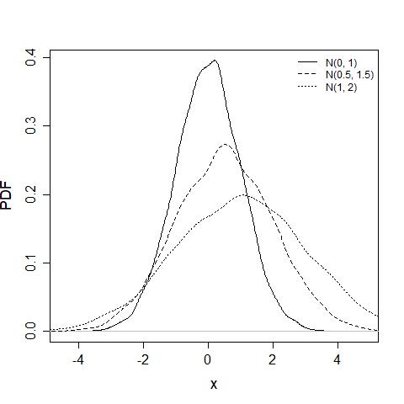
Figure 1. Probability density function of normal distribution with different parameters.

Sub-subsection

Sub-sectioning is only allowed up to level 3, that is, 1.1.1. See Appendix A for information about appendices.

Citations

When citing references in the text type the last name followed by the year of publication in parentheses e.g., Lloyd (1999). The citation may also appear in parentheses (Lloyd, 1999). List all last names of references with two or fewer authors. If there are more than two authors, list the last name of the first author, followed by et al. e.g., Ford et al., (1999). The work done by single author or groups cited within the parentheses must be separated by semi-colon where parentheses contain author(s) surname followed by comma and year of publication e.g., (Ware & Lad, 2003; Ford et al, 1999; Goode & Kao, 1961). List all references at the end of the paper in alphabetical order by primary author's surname. Examples for a paper published in a journal, in conference proceedings, a book etc. are given under the heading References.

Acknowledgment

Any acknowledgements authors wish to make should be included in a separately headed section before References. Acknowledgements, appendices and references need not to be numbered as sections.

Central limit theorem

Appendices are presented before References. They should be clearly labelled as Appendix A etc. The sub-sections in this section can be numbered as below.

Derivation of central limit theorem

The sub-sub-sections in appendix should be avoided.

References

- Ford, I., Torsney, B., & Wu, C. F. (1999). The use of canonical form in the construction of locally optimal designs for non-linear problems. Journal of Royal Statistical Society, Series B,, 54, 569-583.
- Goode, H. P., & Kao, J. H. (1961). Sampling plans based on the Weibull distribution. Proceedings of Seventh National Symposium on Reliability and Quality Control, (pp. 24-40). Philadelphia, Pennsylvania.
- Lloyd, C. J. (1999). Statistical Analysis of Categorical Data. New York: John Wiley & Sons.
- Ware, R., & Lad, F. (2003). Flood frequency analysis of the Waimakariri River. Retrieved from http://www.math.canterbury.ac.nz/research/ucdms2003n17.pdf

* Corresponding author
Department of Statistics, GC University, Katchery road, Lahore-Pakistan. Email: abc@gcu.edu.pk
College of Statistics and Actuarial Sciences, University of the Punjab, Lahore, Pakistan. Email: xyz@gmail.com
Affiliation and Email as given in above examples.

